Crimping of Twisted-Pair Cable with RJ-45 connector for Straight-Through,Cross-Over, Roll-Over.

1. Strip the cable back 1 inch (25 mm) from the end. Insert the cable into the stripper section of the tool and squeeze it tight. Then, rotate the crimping tool around the cable in a smooth and even motion to create a clean cut. Keep the tool clamped and pull away towards the end of the wire to remove the sheathing.[[1]](https://www.wikihow.com/Crimp-Rj45#_note-1)

* The stripping section is a round hole near the handle of the tool.
* The sheathing should come off cleanly, leaving the wires exposed.

2. Untwist and straighten the wires inside of the cable. Inside of the cable you’ll see a bunch of smaller wires twisted together. Separate the twisted wires and straighten them out so they’re easier to sort into the right order.[[2]](https://www.wikihow.com/Crimp-Rj45#_note-2)

* Cut off the small plastic wire separator or core so it’s out of the way.
* Don’t cut off or remove any of the wires or you won’t be able to crimp them into the connector.

3. Arrange the wires into the right order. Use your fingers to put the wires in the correct order so they can be properly crimped. The proper sequence is as follows from left to right: Orange/White, Orange, Green/White, Blue, Blue/White, Green, Brown/White, Brown.[[3]](https://www.wikihow.com/Crimp-Rj45#_note-3)

* There are 8 wires in total that need to be arranged in the right sequence.
* Note that the wires labeled Orange/White or Brown/White indicate the small wires that have 2 colors.

4. Cut the wires into an even line 1⁄2 inch (13 mm) from sheathing. Hold the wires with your thumb and index finger to keep them in order. Then, use the cutting section of the crimping tool to cut them into an even line.[[4]](https://www.wikihow.com/Crimp-Rj45#_note-4)

* The cutting section of the tool will resemble wire cutters.
* The wires must be in an even line to be crimped into the RJ-45 connector properly. If you cut them in an uneven line, move further down the wires and cut them again.

5. Insert the wires into the RJ-45 connector. Hold the RJ-45 connector so the clip is on the underside and the small metal pins are facing up. Insert the cable into the connector so that each of the small wires fits into the small grooves in the connector.[[5]](https://www.wikihow.com/Crimp-Rj45#_note-5)

* The sheathing of the cable should fit just inside of the connector so it’s past the base.
* If any of the small wires bend or don’t fit into a groove correctly, take the cable out and straighten the wires with your fingers before trying again.
* The wires must be inserted in the correct order and each wire must fit into a groove before you crimp the connector.

6. Stick the connector into the crimping part of the tool and squeeze twice. Insert the connector in the crimping section of the tool until it can’t fit any further. Squeeze the handles to crimp the connector and secure the wires. Release the handles, then squeeze the tool again to make sure all of the pins are pushed down.

* The crimping tool pushes small pins in the grooves down onto the wires to hold and connect them to the RJ-45 connector.

7. Remove the cable from the tool and check that all of the pins are down. Take the connector out of the tool and look at the pins to see that they’re all pushed down in an even line. Lightly tug at the connector to make sure it’s attached to the cable.

* If any of the pins aren’t pushed down, put the wire back into the crimping tool and crimp it again.

Tools required for crimping

1. Wire Cutter
2. Wire Stripper
3. Crimp tool

#### Cable certifier

#### Basic cable tester

#### Tone generator and the probe

#### Time domain reflectometer

What is Straight-Through, Cross-Over, Roll-Over.

Straight-Through Wired Cables

Straight-Through refers to cables that have the pin assignments on each end of the cable. In other words, Pin 1 connector A goes to Pin 1 on connector B, Pin 2 to Pin 2, etc. Straight-Through wired cables are most commonly used to connect a host to a client. When we talk about cat5e patch cables, the Straight-Through wired cat5e patch cable is used to connect computers, printers, and other network client devices to the router switch or hub (the host device in this instance).

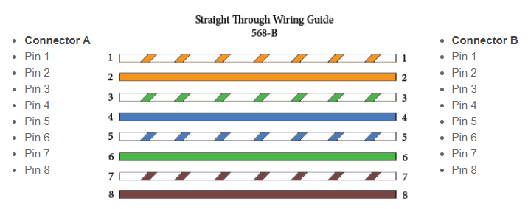

### Crossover Wired Cables

Crossover wired cables (commonly called crossover cables) are very much like Straight-Through cables with the exception that TX and RX lines are crossed (they are at opposite positions on either end of the cable. Using the 568-B standard as an example below, you will see that Pin 1 on connector A goes to Pin 3 on connector B. Pin 2 on connector A goes to Pin 6 on connector B, etc. Crossover cables are most commonly used to connect two hosts directly. Examples would be connecting a computer directly to another computer, connecting a switch directly to another switch, or connecting a router to a router. *Note: While in the past, when connecting two host devices directly, a crossover cable was required. Nowadays, most devices have auto-sensing technology that detects the cable and device and crosses pairs when needed.*

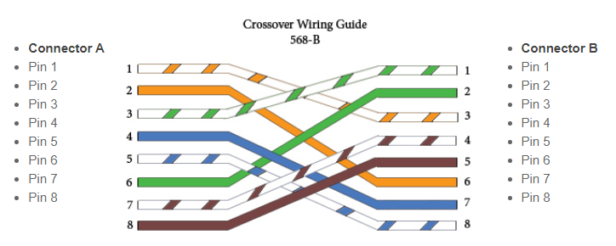

### Rollover Wired Cables

Rollover wired cables, most commonly called rollover cables, have opposite Pin assignments on each end of the cable or, in other words, it is "rolled over." Pin 1 of connector A would be connected to Pin 8 of connector B. Pin 2 of connector A would be connected to Pin 7 of connector B and so on. Rollover cables, sometimes referred to as Yost cables are most commonly used to connect to a device's console port to make programming changes to the device. Unlike crossover and straight-wired cables, rollover cables are not intended to carry data but instead create an interface with the device.

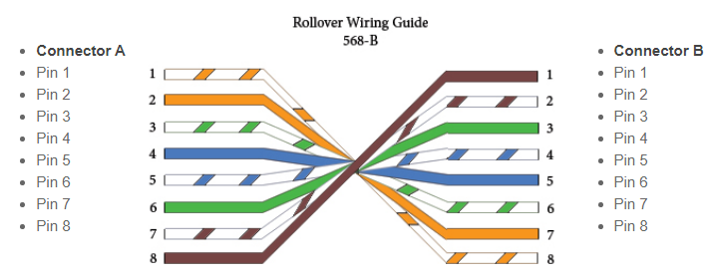

TIA/EIA 568A and TIA/EIA-568B standards(color code)

TIA/EIA 568A and TIA/EIA-568B standards determine the order of the wires placed in the [RJ45 connector](https://www.omnisecu.com/basic-networking/common-network-cable-types.php).

Functionally, there is no difference between TIA/EIA 568A and TIA/EIA-568B standards. Only the difference is that the position of Green and Orange wires are switched.

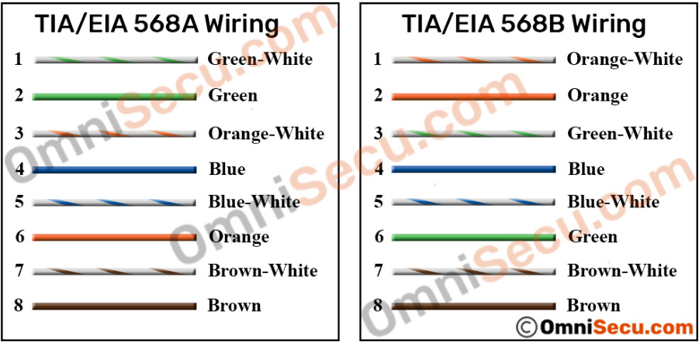

If you terminate the [RJ45 jacks](https://www.omnisecu.com/basic-networking/common-network-cable-types.php) at both ends of a patch cable with same standard (either TIA/EIA 568A on both sides or TIA/EIA 568B on both sides), you will get a [Straight-through cable](https://www.omnisecu.com/basic-networking/straight-through-and-cross-over-cables.php). If you terminate [RJ45 jacks](https://www.omnisecu.com/basic-networking/common-network-cable-types.php) at both ends with different TIA/EIA 568 standards (one side TIA/EIA 568A and other side TIA/EIA 568B) you will get a [Crossover cable](https://www.omnisecu.com/basic-networking/straight-through-and-cross-over-cables.php).